**Hiring Process Analytics**

Kushagra Singh

March 2023

**Description:**

Hiring process is the fundamental and the most important function of a company. Here, the MNCs get to know about the major underlying trends about the hiring process. Trends such as- number of rejections, number of interviews, types of jobs, vacancies etc. are important for a company to analyse before hiring freshers or any other individual. Thus, making an opportunity for a Data Analyst job here too!  
  
In this data analytics project I have gone through these trends and drawn insights out of it for hiring department to work upon.  
I have considered myself working in Google as a lead Data Analyst and the company has provided me with the data records of their previous hirings from which I have answered certain important day to day questions.

**Approach:**  
  
The dataset of a company used contains the details about people who registered for a particular post in a department of this company. I have used knowledge in statistics and use different formulas in excel and draw necessary conclusions about the company.  
  
Below EDA steps are involved before using the data

1. Understanding data columns and data
2. Checking for missing data
3. Clubbing columns with multiple categories
4. Checking for outliers
5. Removing outliers
6. Drawing Data Summary

Here I have used MS Excel and various Statistical Concepts.

1. **Hiring:** Process of intaking of people into an organization for different kinds of positions.

|  |  |
| --- | --- |
| Status | Hired |
|  |  |
| **Row Labels** | **Count of event_name** |
| Female | 1856 |
| Male | 2563 |
| **Grand Total** | **4419** |

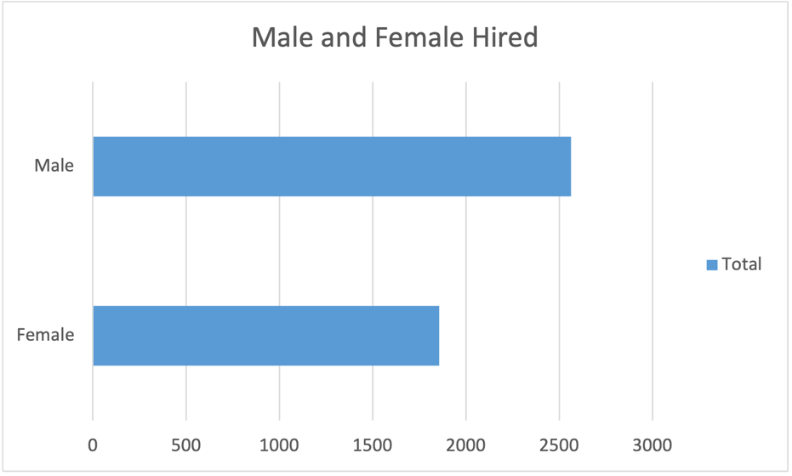

1. **Average Salary:** Adding all the salaries for a select group of employees and then dividing the sum by the number of employees in the group.

Average Salary of the company is average of the salary calculated without outliers. Average Salary of the Company is 49892.13474

1. **Class Intervals:** The class interval is the difference between the upper class limit and the lower class limit.

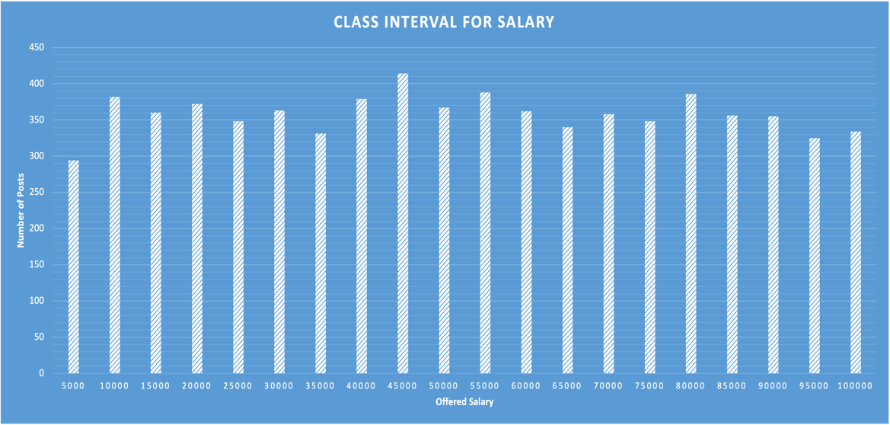

1. **Charts and Plots:**This is one of the most important part of analysis to visualize the data.

|  |  |
| --- | --- |
| **Department** | **Count of Department** |
| Human Resource Department | 97 |
| General Management | 172 |
| Finance Department | 288 |
| Marketing Department | 325 |
| Purchase Department | 333 |
| Production Department | 380 |
| Sales Department | 747 |
| Service Department | 2055 |
| Operations Department | 2771 |
| **Grand Total** | **7168** |

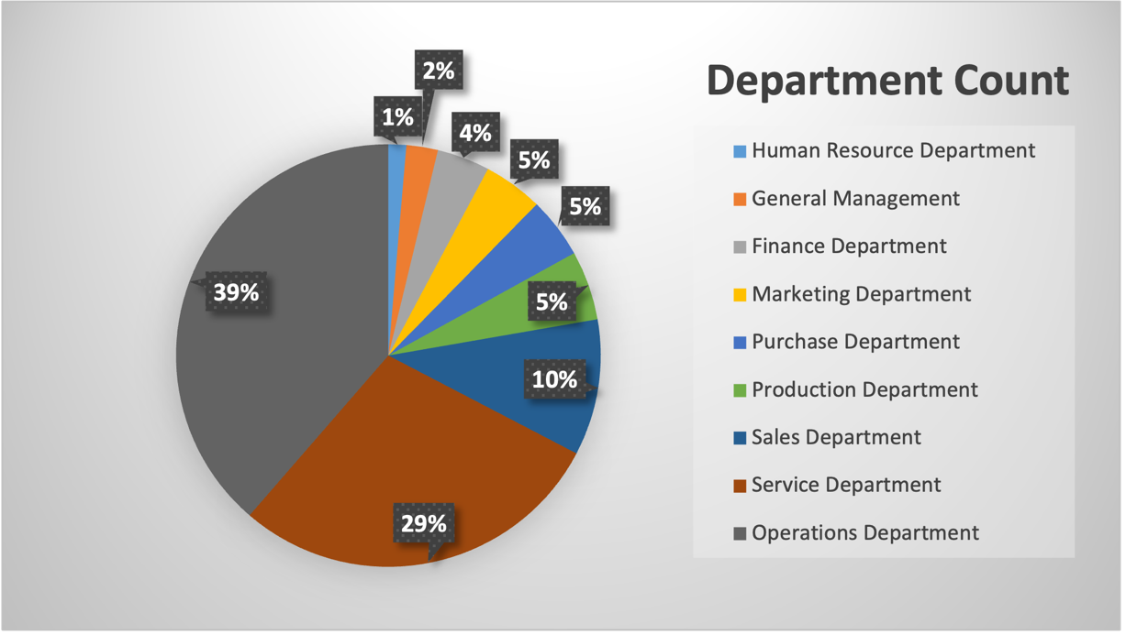

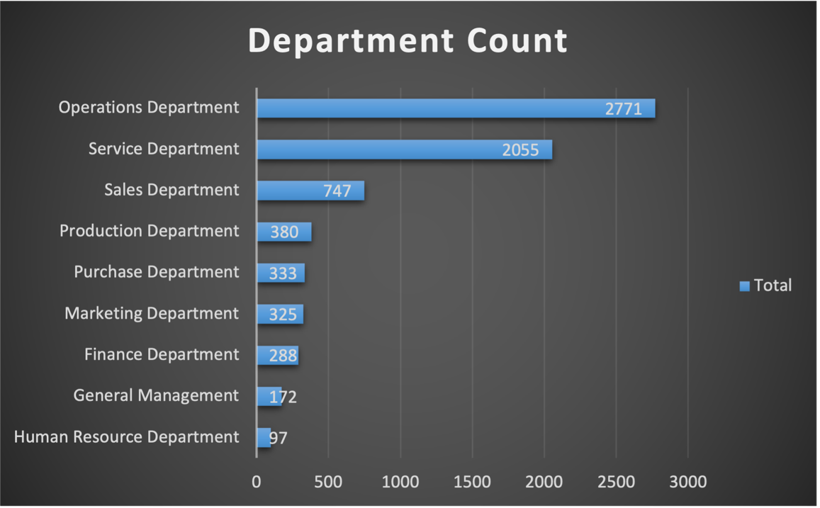

1. **Charts:**Use different charts and graphs to perform the task representing the data.  
   **Your task:**Represent different post tiers using chart/graph?

|  |  |
| --- | --- |
| Status | Hired |
|  |  |
| **Row Labels** | **Count of Post Name** |
| - | 1 |
| n6 | 1 |
| m6 | 2 |
| i4 | 32 |
| c-10 | 105 |
| i1 | 151 |
| c8 | 193 |
| b9 | 308 |
| i6 | 337 |
| i5 | 511 |
| i7 | 635 |
| c5 | 1182 |
| c9 | 1239 |
| **Grand Total** | **4697** |

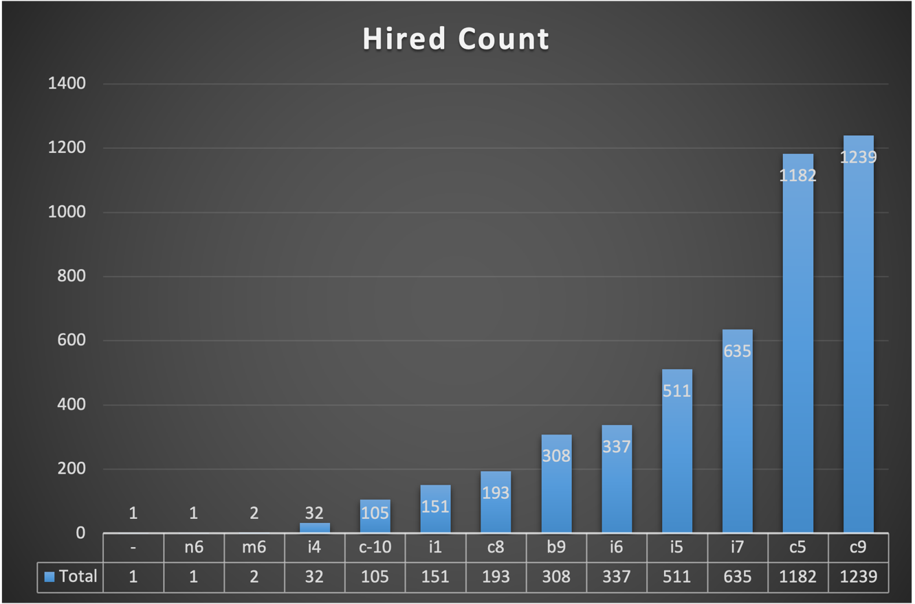

|  |  |
| --- | --- |
| Status | (All) |
|  |  |
| **Row Labels** | **Count of Post Name** |
| n9 | 1 |
| n10 | 1 |
| n6 | 1 |
| - | 1 |
| m7 | 1 |
| m6 | 3 |
| i4 | 88 |
| i1 | 222 |
| c-10 | 232 |
| c8 | 320 |
| b9 | 463 |
| i6 | 527 |
| i5 | 787 |
| i7 | 982 |
| c5 | 1747 |
| c9 | 1792 |
| **Grand Total** | **7168** |

